‘‘Trapped’’
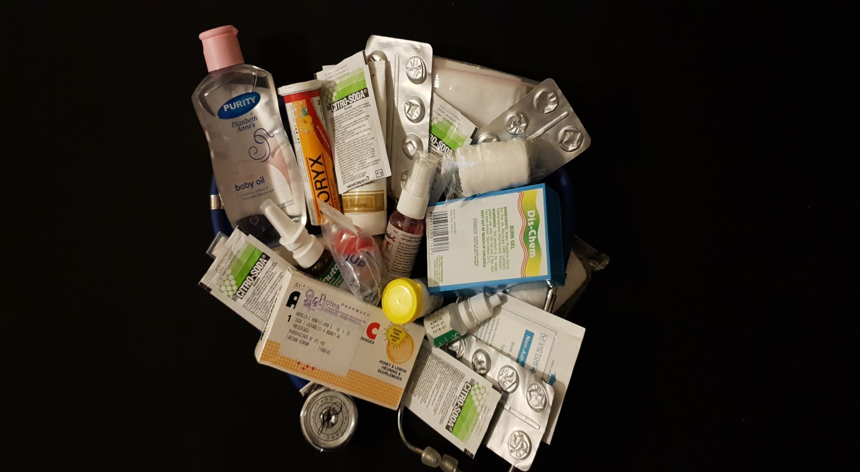

Studies have shown that the amount of people suffering from chronic disease in South Africa has increased over the last few years. Amy Stenehjem said; ‘‘chronic illness is a disease, condition, or injury that can last years or a lifetime and is typically not curable, though in some cases it may go into remission. It can vary in its severity, with some people able to work and live active or seemingly “normal” lives; while others are very sick and may even be homebound’’(2017).
To me the picture above represents being trapped. The stethoscope provides a border which represents the life of a person who is suffering from a chronic disease and the surface area between is filled with a variety of medication to represent what the person’s life is filled with. People suffering from chronic diseases often have to rely on medication to keep them performing at their highest level of function. Without the medication their conditions may worsen and their lives would have to change more than they already have.
As an example of a chronic disease I have chosen to focus on asthma to provide a broader perspective on how patients rely on their medication. A patient suffering from asthma is required to always have their bronchodilator on hand. In severe cases, if untreated an asthma attack could lead to death. Other than needing the bronchodilator when having an attack, some patients are required to use different mixtures of medication at certain times during the day as a preventative measure. This means having to always have the medication with you if you are leaving for a long period of time and also having to constantly go to the doctor, pharmacy or clinic to have your prescriptions and medication refilled. In South Africa, Asthma prevalence is estimated to be on the region of “5.1 - 7.1%” of the population (Cairncross; 2018).
Due to the increase in sufferers from chronic conditions, places intended for health care such as clinics and hospitals are always crowded and patients wait for hours before being attended to. Some conditions are more life threatening than others and patients cannot just leave and go back on a day when it is less crowded. This further reinforces their dependence on health care professionals to provide them with the care they need in order to survive.

Reference List
- Cairncross, C.A. (2018, May). Prevalence of chronic diseases in the population covered by medical schemes in South Africa. Retrieved from: http://www.medicalschemes.com/files/Research%20Briefs/Prevalence2018.pdf on 08/05/2019.
- Stenehjem, A. (2017, November). I’m A Doctor With Chronic Illness. Here Are 12 Things I Wish People Knew. Retrieved from: https://www.huffpost.com/entry/im-a-doctor-with-chronic-illness-here-are-12-things_n_5a1d33f0e4b09413e786aec1?guccounter=1&guce_referrer=aHR0cHM6Ly93d3cuZ29vZ2xlLmNvbS8&guce_referrer_sig=AQAAAMbSyxr5EZA9tyvfQicUECEqj_s90q-U4pMYdjYldFCMUeOFS27aa_bHNZkpBS5uTaDM1s7ZNExpFupvMjy23-9wvb6PnGc3tKiThXUeLNrIvq0AqOsW7yklYFDNOCqtXQapDgaE_DGJUcSmka0CtspRLLs_d8M4UGay0wZjpTpx on 08/05/2019.

